

**Tiger Computer Services Ltd**

|  |  |
| --- | --- |
| Author : |  |
| Date : | 23 OCT 2011 |
| Version : | 0.0.1 |
| Status : | DRAFT |

For any issues or queries arising from the contents of this document please contact Tiger Computer Services Ltd

email: [liam.westley@tigernews.co.uk](mailto:liam.westley@tigernews.co.uk)

Contents

1 Document control 3

1.1 Document information 3

1.2 Document revision history 3

1.3 References 3

2 Document objective 4

2.1 Windows XP Professional Service Pack 3 4

2.2 Pre-requisites 4

2.3 Administrator User for SQL Server 4

3 Microsoft SQL Server 2008 R2 Express with Advanced Services 5

3.1 Installation 5

3.2 Configuring the first data connection, and some folders 15

4 Microsoft SQL Server Report Builder (3.0) 17

4.1 Creating a simple report 19

# Document control

## Document information

|  |  |
| --- | --- |
| Title |  |
| Subject |  |
| Author |  |
| For review by |  |
| For approval for internal distribution by |  |
| For approval for submission by |  |
| Distribution |  |
| Filename |  |

## Document revision history

|  |  |  |  |
| --- | --- | --- | --- |
| Version | Date | Author | Comments |
| 0.0.1 | 23 OCT 2011 | Liam Westley | Created |

## References

|  |  |  |  |
| --- | --- | --- | --- |
| No. | Originator | Title | Version |
| 1 |  |  |  |

# Document objective

The goal of this document is to document the installation and configuration of SQL Server 2008 R2 Express with SQL Server Reporting Services on a vanilla installation of Windows XP Professional Service Pack 3.

## Windows XP Professional Service Pack 3

Windows XP Professional was installed as a 32-bit operating system with the latest Windows Updates including Internet Explorer 8.0 and Windows .Net 4.0 client profile.

It is quite possible that some of the pre-requisites for installation of SQL Server and Reporting Services would already be present on an XP client that was used day to day due to other installations. However, these have also been listed for completeness.

## Pre-requisites

The pre-requisites were installed in the order below, ignoring option to restart machine until all were installed.

### Windows installer 4.5

Google ‘download Windows Installer 4.5’

<http://www.microsoft.com/download/en/details.aspx?id=8483>

### .NET 2.0 SP2 and requires .NET 3.5 SP1

Google, ‘download .Net 2.0 SP2’ – NetFx20SP2_x86.exe.

<http://www.microsoft.com/download/en/details.aspx?id=1639>

Google, ‘download .Net 3.5 SP1’ - this generally leads to a small ‘internet downloader’ that downloads the necessary components on the fly and installs them as required (29Mb for XP SP3).

<http://www.microsoft.com/download/en/details.aspx?id=22>

### Powershell 2.0

Google ‘download Powershell 2.0’ – however, there are many versions, so direct download link for Windows XP (WindowsXP-KB968930-x86-ENG.exe) is,

<http://www.microsoft.com/download/en/confirmation.aspx?id=16818>

### Windows Update

And after installing all those packages, a Windows Update was run again to patch these fresh installations. These tend to be security

## Administrator User for SQL Server

It would be advisable to create a local administration user specifically for SQL Server with a different password to standard administration users. This should be added to the Administrators group.

This logon will be used for managing SQL Server via SQL Server Management Studio and for configuring Reporting Services, including providing access to the core prisoner details database (by default, all administrators on system automatically become administrators on SQL Server installed on a system).

# Microsoft SQL Server 2008 R2 Express with Advanced Services

There are numerous versions of SQL Server Express, some of which are smaller installations which do not include management tools or reporting services. To ensure you obtain the version with all the tools, Google for,

‘Sql Server 2008 R2 Express Advanced Services’

This should locate the page **Microsoft SQL Server2008 R2 RTM - Express with Advanced Services**, where you should select the download, **SQLEXPRADV_x86_ENU.exe** (727.0 MB).

By default the installation will be created in *C:\Program Files\Microsoft SQL Server*, with the database files stored in the folder, *C:\Program Files\Microsoft SQL Server\MSSQL10_50.SQLEXPRESS\MSSQL\DATA*.

## Installation

Run the SQLEXPRADV_x86_ENU.exe, this will run Microsoft SQL Server 2008 R2 setup (common to all versions of Microsoft SQL Server 2008 R2) where you can configure a new *instance* of SQL Server. When connecting to SQL Server the name of the server is usually given in the format **<machineName>\<instanceName>**.

SQL Server runs as a set of Windows Services, running all the time in the background. Reporting Services also runs as a Windows Services providing two ‘web sites’, a web service used by the Report Designer application and a reporting manager URL for end users to access reports via a web browser.

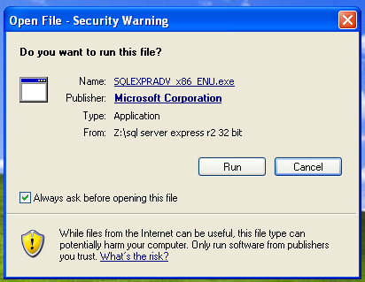

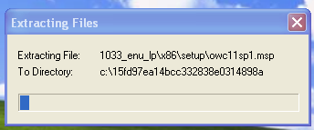

Select *New installation or add features to an existing installation,* accept the license terms and click *Next*. The installation will then configure the *Setup Support Files*. If all the pre-requisites have been installed properly it should progress to the next step.

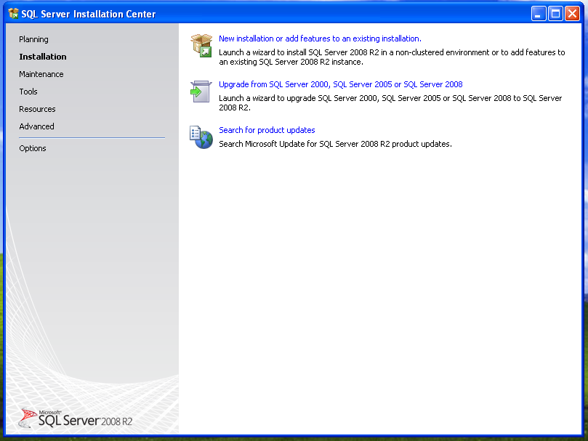

Select all options (highlighted by default), and click *Next*,

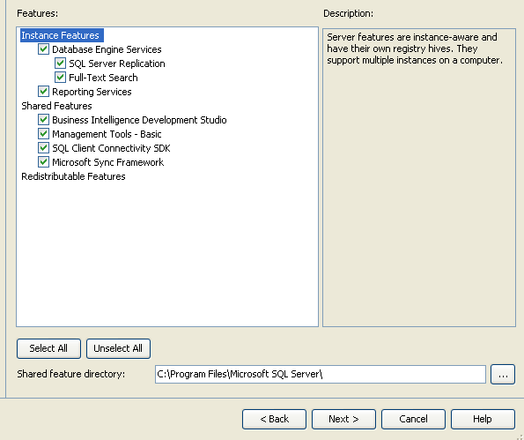

Leave the default instance name as *SQLExpress* with the default paths, then click *Next*,

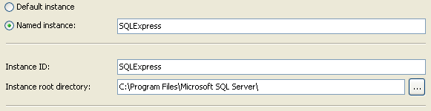

For running the SQL Server services, set the *Account Name*, to *NT_AUTHORITY\NETWORK_SERVICE* (no password required) for all three services where the account name is are blank, then click *Next*,

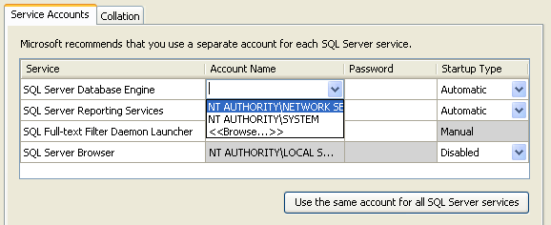

Leave the security mode as *Windows authentication mode*, add any additional administration users, and then click on *Next*,

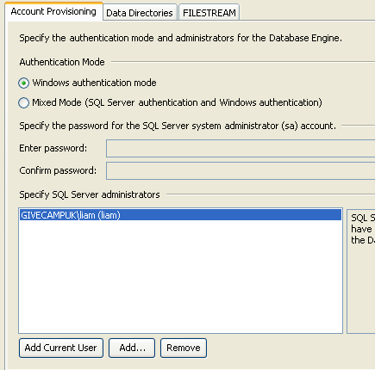

Leave the next screen as *Install the native mode default configuration*, and click on *Next,* and then *Next* again,

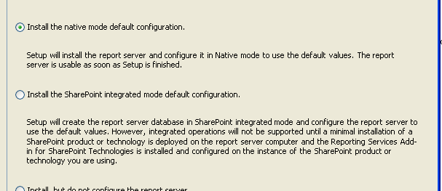

The installation will then begin,

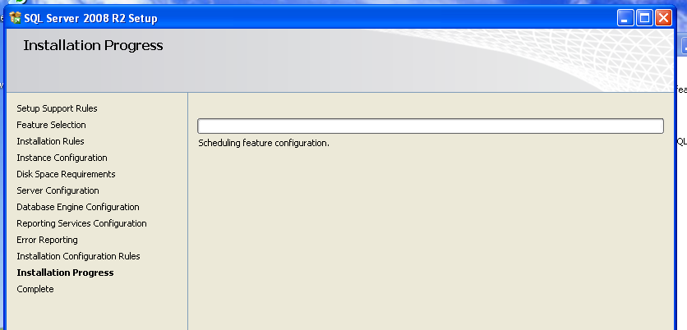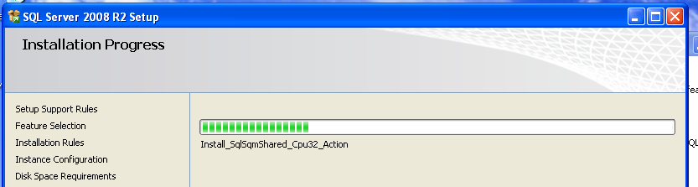

Successful installation, click on *Close* and restart the system,

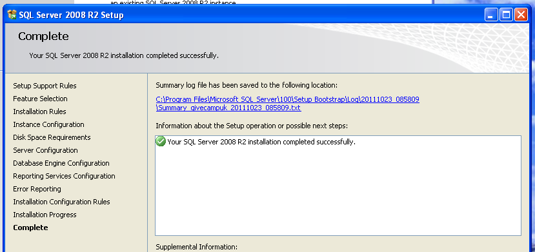

### Configuration of SQL Server 2008 R2 Express

By default SQL Server 2008 R2 Express is installed in a highly secure configuration, so secure that the database will not be accessible outside of the machine on which it is installed. To configure access to the database from other machines on the local network you need to run the SQL Server 2008 R2 configuration manager, Start Menu -> All Programs,

Microsoft SQL Server 2008 R2 -> Configuration Tools -> SQL Server Configuration Manager

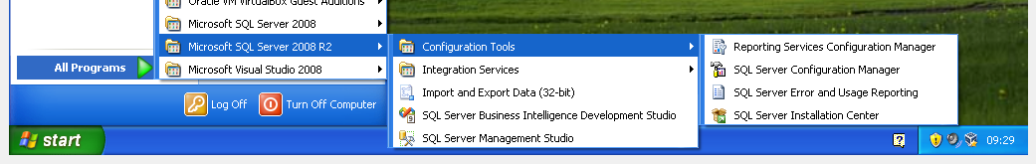

Expand the *SQL Native Client 10.0 Configuration* section, and highlight *Protocols for SQLEXPRESS*, and then right click on *TCP/IP* and select *Enable*, and right click on *Named Pipes* and select *Enable.* Restart the services (or the system) to apply the changes.

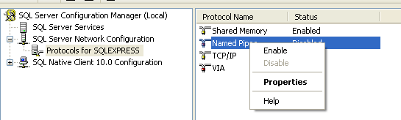

The SQL Server 2008 R2 Express installation is now ready to have the data migration tool run across it to import the database into a database.

### Configuration of Reporting Services

Once SQL Server 2008 R2 Express has been installed you can configure reporting services, Start Menu -> All Programs,

Microsoft SQL Server 2008 R2 -> Configuration Tools -> Reporting Services Configuration Manager

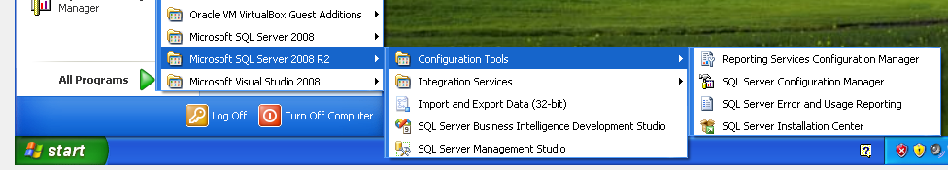

When this first starts you need to provide a *Server Name* (the machine name) and the *Instance Name* (the one we configured during installation, *SQLExpress*)

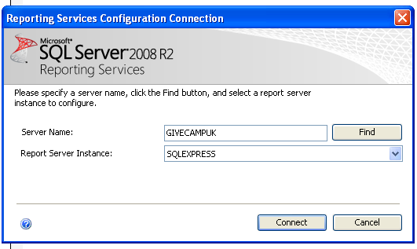

Once started you should be viewing a screen something like,

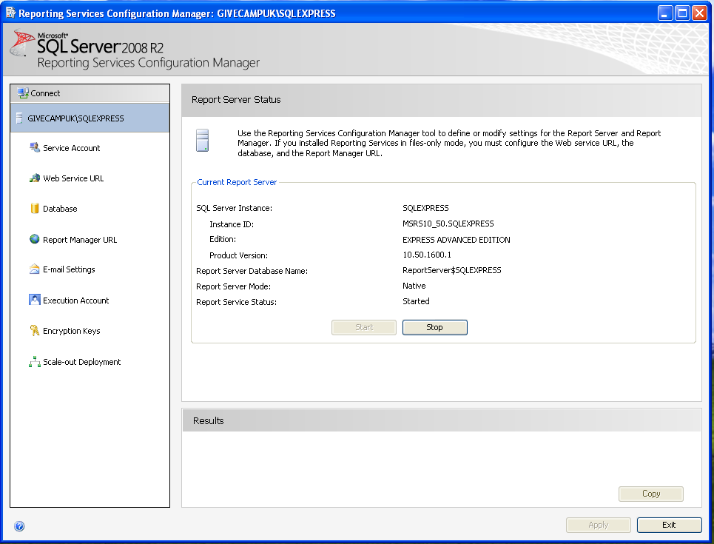

The first step is to set the *Execution Account* under which the reporting services will access the SQL Server databases, configure this to be the administrator user you created earlier and click on *Apply*.

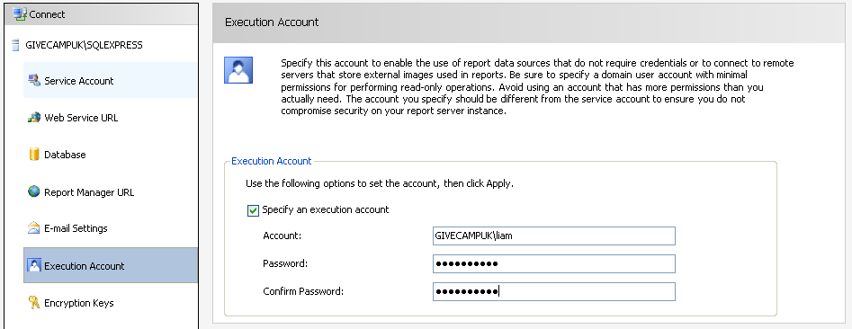

One of the options on the left hand menu is, **Web Service URL** (as used by the Report Designer), you should now be able to click on the URLs link to view the web service URL in Internet Explorer,

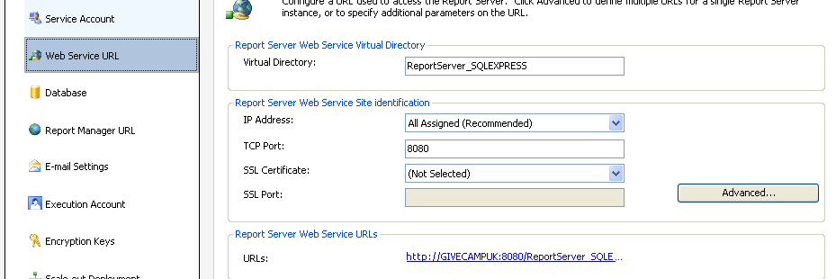

This will prompt for a user name for access (it’s secure to prevent non authorised access, as this is how you manage reporting services), and you’ll then probably get a blank page in Internet Explorer,

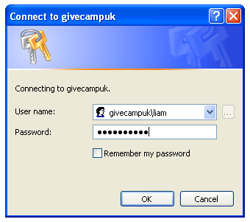

The reason this is useful is we can copy the URL from Internet Explorer as required by the Report Designer later,

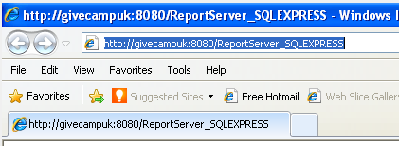

Another option on the left hand menu is, **Report Manager URL** (as used by end users to manage and view reports, works best in Internet Explorer) , you should now be able to click on the URLs link to view the report manager URL in Internet Explorer,

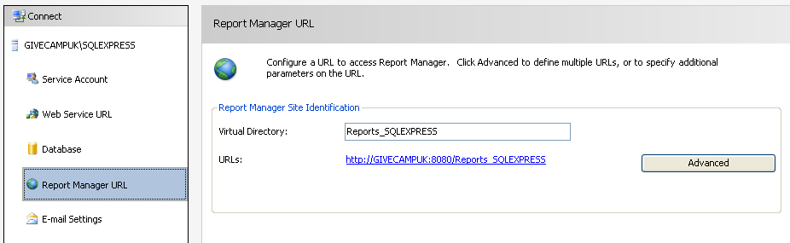

The first time you access a reporting server it may take some time to display the first page, and it will then be much faster for subsequent users. Eventually you will see the following screen,

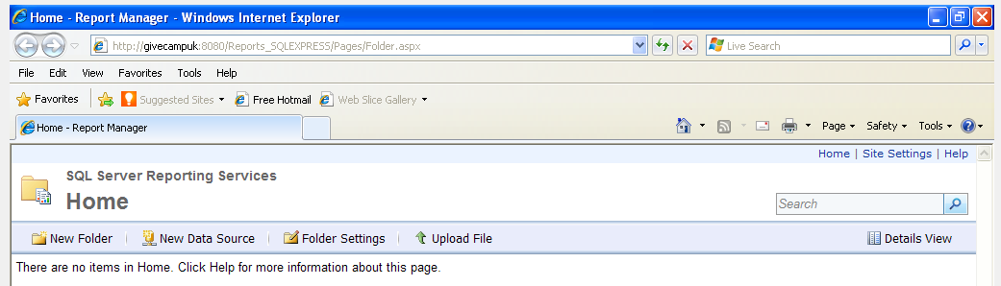

## Configuring the first data connection, and some folders

As we have the Report Manager web site open in Internet Explorer we might as well configure a few items, including the database connection used for reports. Click on *New Folder*, and create a new folder called *Database connections* and click on *OK*,

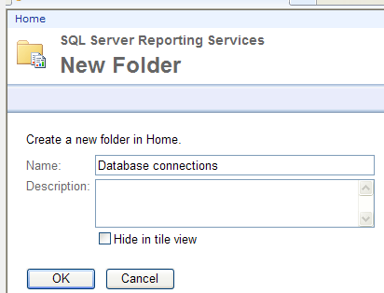

You might also create a few more folders,

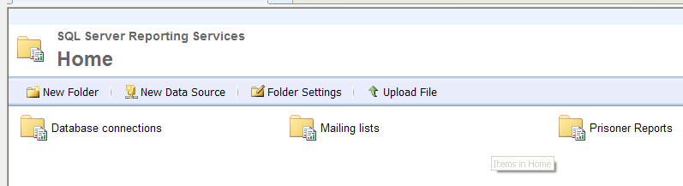

Click on the *Database connections* folder to open it and click on the *New Data Source* option to create a new connection to the database. You will need to provide a database name (*Initial Catalog*) and a server/instance name (*Data Source*) in the *Connection string* text area, and click on *Windows Integrated Security* to provide access to the database*.* Click on *Test Connection* to ensure it is configured correctly. Then click on *OK* to save the connection,

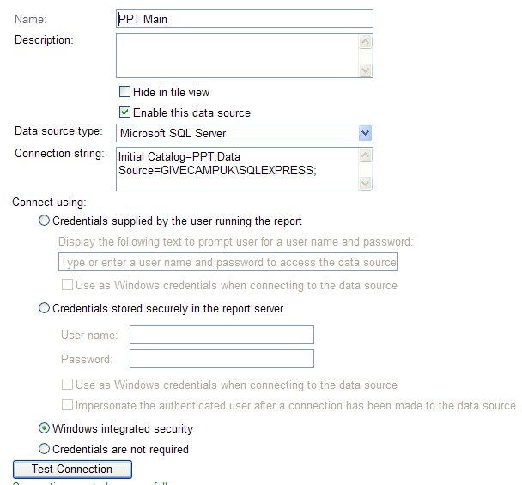

Now we have a database connection configured in the Reporting Manager and some folders we can install the SQL Server 2008 R2 Report Builder 3.0

# Microsoft SQL Server Report Builder (3.0)

Google, ‘SQL Server 2008 R2 Report Builder 3.0’, and download the file, **1033\x86\ReportBuilder3.msi** (31.0Mb),

<http://www.microsoft.com/download/en/details.aspx?displaylang=en&id=6116>

When you run the MSI setup file you may receive the standard security warning, click *Run* and then *Next* on the splash screen,

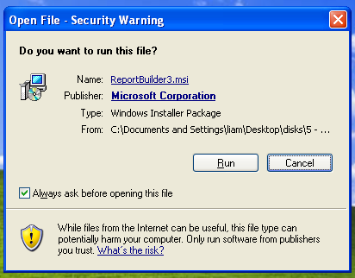

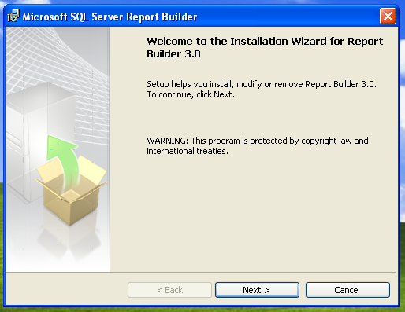

Accept the license agreement, click *Next*,

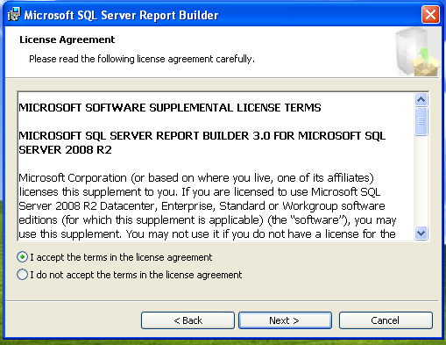

You will then be asked for the target server URL, which is the **Web Service URL** we noted from the *Reporting Service Configuration Manager* earlier. Once entered click *Next* and *Install*.

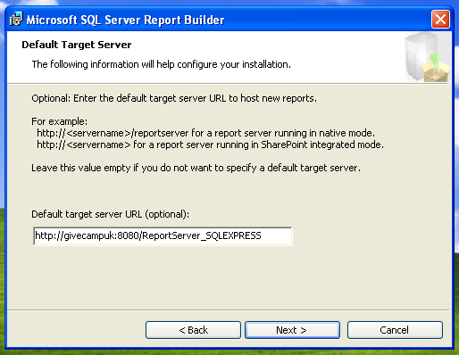

We can then run the Report Builder from*,*

*Start Menu -> All Programs -> Microsoft SQL Server 2008 R2 Report Builder 3.0 -> Report Builder 3.0*

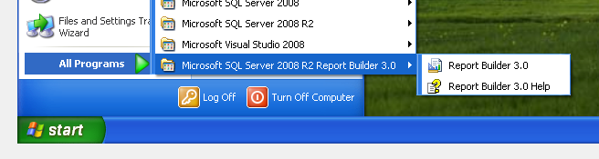

## Creating a simple report

When first starting the report manager you will see the create new report wizard,

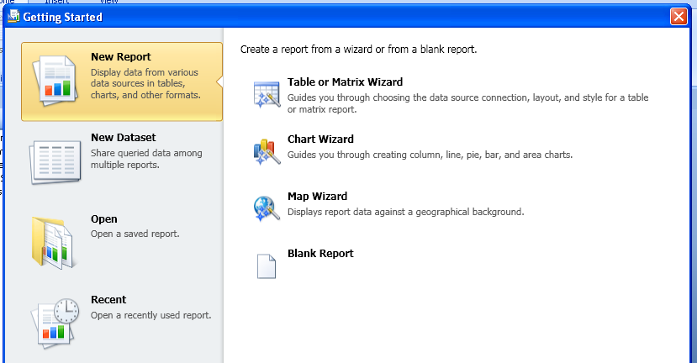

Select *New Report* and *Table or Matrix Wizard,* and on the next screen make sure *Create a Dataset* is highlighted and click on *Next*.

Click on *Browse* to browse the reporting server, go into the *Database connections* folder we created earlier and select the *PPT Main* data source we also created earlier, and click on *Open*, then *Next*.

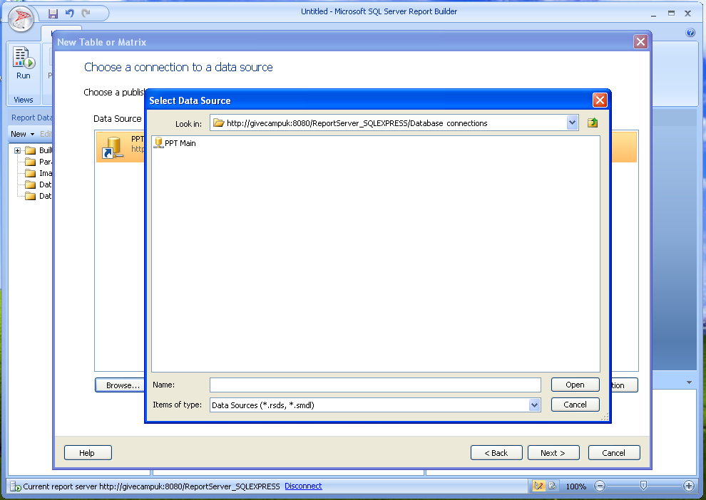

In the *Design a query* wizard open the *Tables* area, open the *Contacts* table, select some fields, and then click on the new filter button towards the right hand side (the funnel with an gold star on it), and add a filter on Surname, where it is *LIKE* a value supplied by the user. To ensure the user is prompted for a value, put a tick in the *Parameter* box. This is what makes a text box appear on the form for the user to query the data. Click on *Next* when complete.

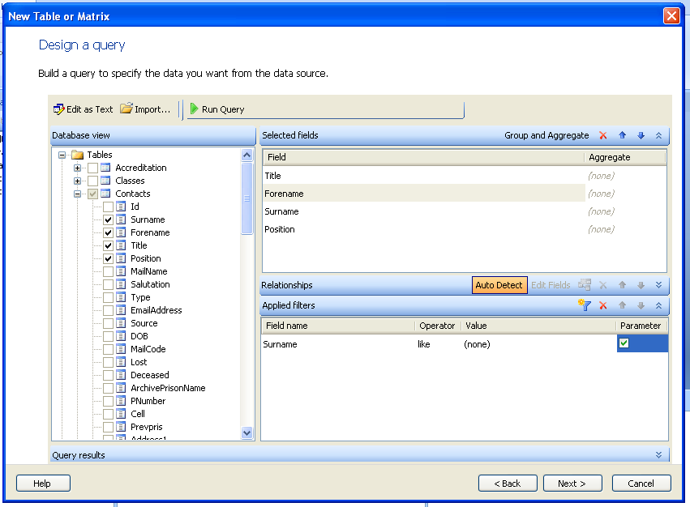

Now we have specified what data we are selecting and how it is filtered, we need to select the data to be displayed in the search result, in the *Arrange Fields* screen. Select the fields to be displayed and for a simple table click and drag them over to the *Values* box (hint: when clicking to drag them, click on an actual field name, not the blank space after the field name).

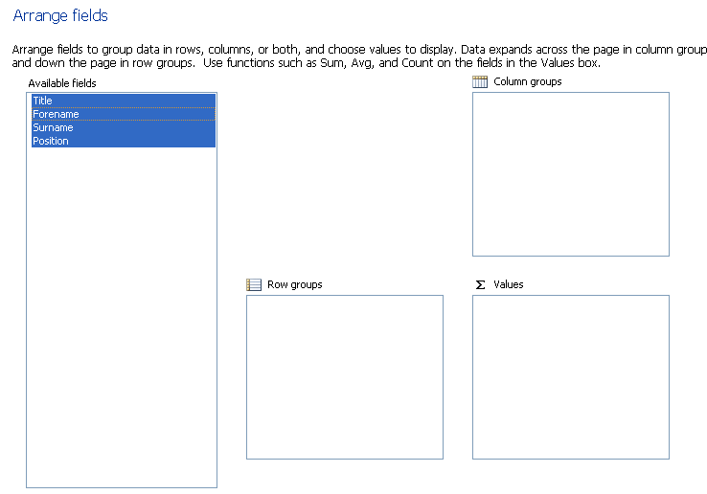

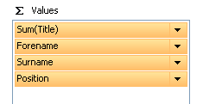

You can then select a layout, with some default styling and click on *Finish* to complete the report.

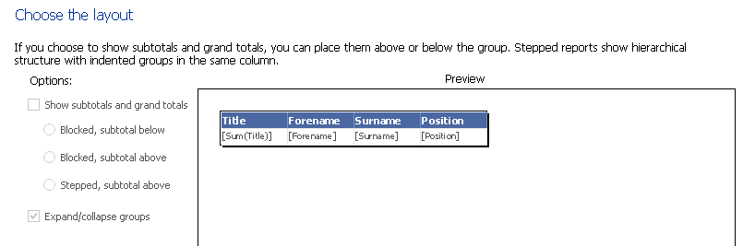

This is not yet deployed to the Reporting Server for end users, but you can test the report within the report designer by clicking on the *Run* icon.

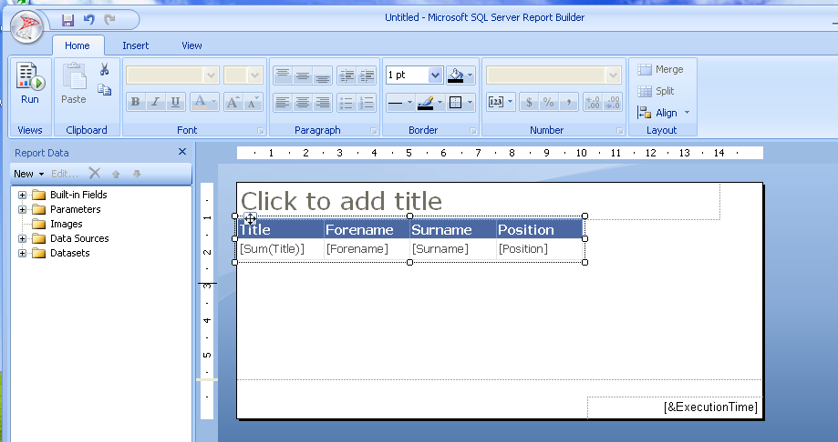

You can then run the report, put in a test name, say *%len%*, and hit *Enter* or click on *ViewReport*,

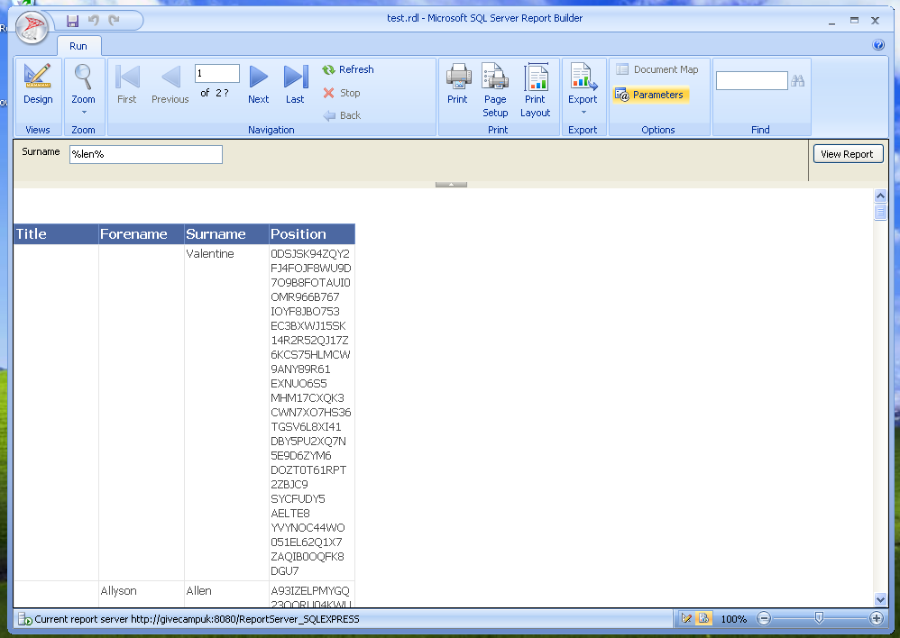

We had to use % to wildcard the search. One way to make it easier for the user is to go back to the report designer (click on the *Design* icon), open the *Datasets* part of the tree, right click the dataset, *DataSet1*, and select *Dataset Properties* from the popup menu.

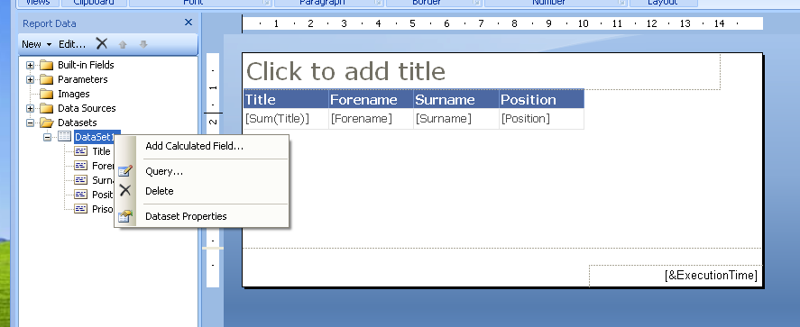

This will display the Dataset Properties dialog, including the Query being used to generate the report,

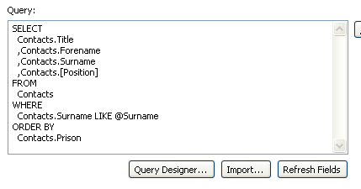

Avoiding the *Query Designer* , we can edit the SQL query directly and add the % wildcards so the end user no longer has to enter them,

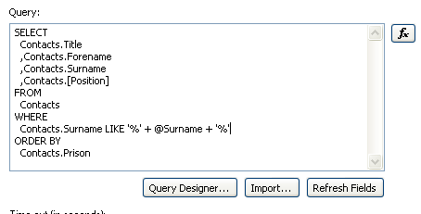

You can now run the report again without typing in the % symbols,

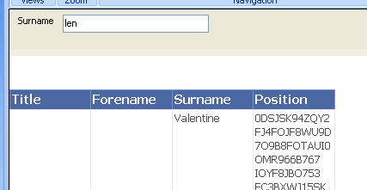

### Saving the report to the report server

When you click on Save (the disc icon) or click on Save As you get the standard save dialog, which includes the ability to save to *Recent Sites and Servers* as well as the file system. In this you can select your report server and then navigate to a folder where the report should be located,

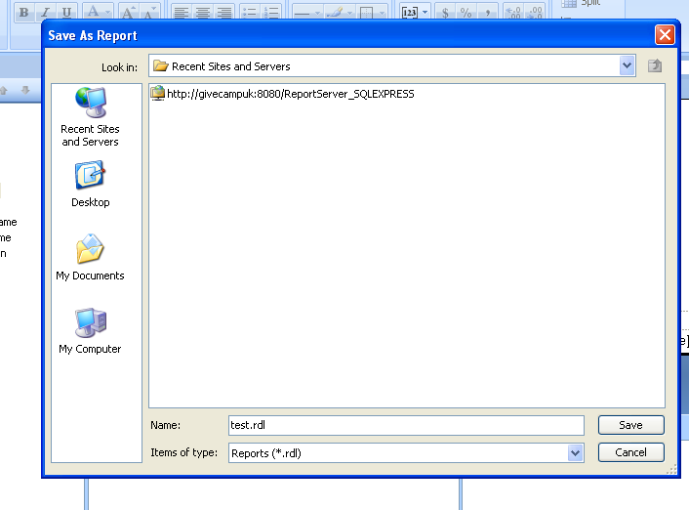

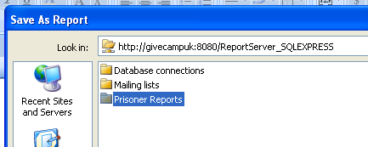

Once you have the folder name you want selected, enter a *Name* for the report, say *PrisonerDetails* and then click on *Save*.

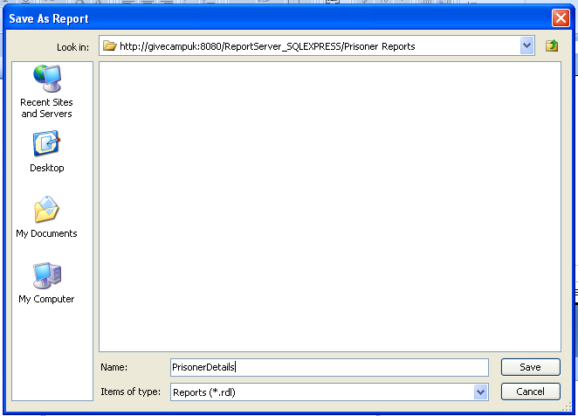

### Viewing the report as a normal user

Now we can use Internet Explorer to view the report,

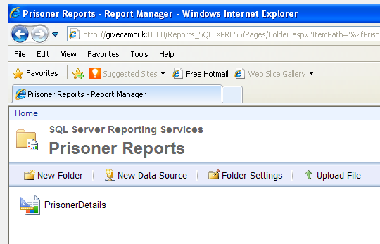

When you click on the *PrisonerDetails* report you can then enter a partial surname and click *Enter*,

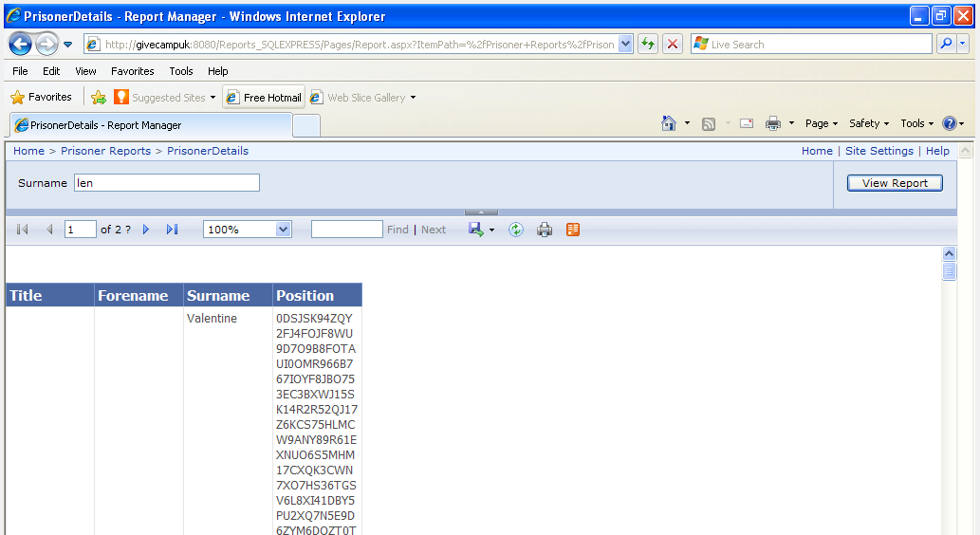

On the toolbar above the report (the one with paging) you can use the floppy disc icon with a green arrow to export the data to PDF, Excel or Word format for processing later.

